Islamic Financing Module for Loan Management System (LMS)
1 Overview
1.1 Ressources
1.2 Objective
1.3 Scope
1.4 Out of Scope
1.5 Existing System Behavior (Out-of-the-Box)
1.6 Design Principles
2. Module Configuration
2.1 Product Feature Enablement (License Configuration)
2.2 New System Configuration
3. Loan Product Configuration
Figure 1 - Loan Product configuration screen
3.1 Required Changes
3.2 Business Rules
Figure 2 - Loan Product configuration screen: "Islamic Product" toggle and conditional "Financing Type" dropdown
3.3 Validations
3.4 Impact
4. Terminology Mapping
4.1 Required Changes
4.2 Default Grid Values
4.3 Business Rules
4.4 Scope
5. Financing Creation
5.1 Required Changes
5.2 Business Rules
5.3 Validations
5.4 Existing Screen Changes
6. Financing Schedule
6.1 Required Changes
6.2 Business Rules
6.3 Validations
6.4 Impact
7. Financing Account – General Tab
7.1 Required Changes
7.2 Business Rules
7.3 Validations
7.4 Impact
8. Financing Account Details
8.1 Required Changes
8.2 Business Rules
8.3 Validations and Display Handling
8.4 Impact
9. Financing Repayment
9.1 Required Changes
9.2 Payment Allocation
9.3 Business Rules
10. Financing Transactions
10.1 Required Changes
10.2 Transaction List
10.3 Transaction Details
10.4 Business Rules

1 Overview

1.1 Ressources
- Product Owner: Petra Al Ammar / Sami Soudah
- Project Manager: Dany Hoyek
- Technical Lead: Hussein Fares
- Target Completion Date:
- Epic:

1.2 Objective
The objective of this enhancement is to extend the existing Loan Management System (LMS), to support Shariah-compliant financing while preserving the existing conventional lending capabilities and maintaining full backward compatibility.
The module is designed as an optional product capability that enables financial institutions to offer Islamic financing products alongside conventional lending within the same Core Banking System (CBS). It leverages the existing loan lifecycle, repayment processing, accounting integration, APIs, security model, and operational workflows provided by the LMS, minimizing changes to the core platform while ensuring full backward compatibility.
The implementation shall initially support Murabaha Financing while providing a scalable foundation for future Islamic financing contracts, including Ijara, Musharaka, Salam, Istisna, Tawarruq, and other financing models.
The module follows a configuration-driven architecture, allowing each financial institution to enable or disable Islamic financing capabilities based on its business requirements, regulatory obligations, and Shariah governance policies.

1.3 Scope
This enhancement includes the following capabilities:
- Configuration-driven Islamic Financing Module.
- Tenant-level enablement or disablement of Islamic financing.
- Product-level Islamic financing configuration.
- Support for Murabaha financing (Phase 1).
- Financing Type framework to support future Islamic financing contracts.
- Islamic terminology and configurable labels.
- Commodity reference and supplier information.
- Cost Price, Profit, and Selling Price management.
- Financing schedule generation.
- Financing details enhancements.
- Repayment processing enhancements.
- Transaction history enhancements.
- API enhancements.
- Audit logging.
- Role-based permissions.
- Integration with external Commodity Management systems.

1.4 Out of Scope
The current FRD does not include:
- Commodity trading or marketplace functionality.
- Commodity ownership lifecycle management.
- Islamic General Ledger or AAOIFI accounting engine.
- Islamic treasury operations.
- Profit distribution for investment accounts.
- Regulatory reporting specific to Islamic banking.
These capabilities may be introduced as independent product modules in future releases.

1.5 Existing System Behavior (Out-of-the-Box)
The existing Loan Management System provides a mature conventional lending engine with comprehensive support for loan product configuration, loan lifecycle management, repayment schedules, transaction processing, accounting integration, REST APIs, maker-checker workflows, and audit logging.
However, the current implementation is designed for conventional interest-based lending and does not natively support Shariah-compliant financing concepts such as financing contracts, commodity-based financing, profit-based calculations, or Islamic financing terminology.
The Islamic Financing Module extends the existing loan engine by introducing these capabilities while preserving the standard behavior of conventional lending products.

1.6 Design Principles
The Islamic Financing Module is designed according to the following principles:
- Configuration-Driven: Islamic financing capabilities are enabled through configuration without requiring source code modifications.
- Modular: The module can be enabled or disabled independently of conventional lending.
- Backward Compatible: Existing conventional loan products and processes remain unaffected.
- Extensible: The architecture supports additional Islamic financing contracts without redesigning the core loan engine.
- Product-Oriented: The module provides reusable product capabilities that can be configured to meet the requirements of different financial institutions.
- Integration Ready: Standard APIs support integration with external commodity management, accounting, digital banking, and third-party systems.
- Secure and Auditable: All business operations are governed by role-based permissions, maker-checker controls, and comprehensive audit logging.

1.7 Product Architecture
The Islamic Financing Module extends the existing Loan Management System by introducing configurable Islamic financing capabilities while reusing the existing financing lifecycle, repayment engine, accounting integration, APIs, security model, and operational workflows.
The module consists of the following functional components:
- Module Configuration
- Product Configuration
- Financing Types
- Terminology Mapping
- Financing Lifecycle
- External Integrations
- REST APIs
- Audit & Security

2. Module Configuration
The Islamic Financing Module is an optional product module within the Loan Management System (LMS). The module is controlled through two levels of configuration:
- Product Feature Enablement (License Configuration) → Determines whether the Islamic Financing Module is available for the tenant.
- Business Configuration → Determines how the module behaves once it has been enabled.

2.1 Product Feature Enablement (License Configuration)
The Islamic Financing Module shall be controlled by a product feature flag that is managed outside the CBS Administration Portal.
This configuration is intended for product licensing and feature management and determines whether the customer has access to the Islamic Financing Module.
Configuration | Type | Default | Description
Islamic Financing Module | Boolean | Disabled | Enables or disables the Islamic Financing product module for the tenant.
Behavior
When Disabled
- The Islamic Financing Module is not available.
- Islamic menus and configuration screens are hidden.
- Islamic APIs are not exposed.
- Islamic validations are not executed.
- Existing conventional lending functionality remains unchanged.
When Enabled
- The Islamic Financing Module becomes available.
- Islamic configuration menus are displayed.
- Islamic financing products can be configured.
- Islamic APIs become available.
- Business-level configuration can be managed through the Administration Portal.

2.2 New System Configuration
Introduce new system configurations required to enable and manage Islamic Financing.
Navigation
Admin → System → Configurations
Add the following system configurations:
Configuration | Type | Default | List Of Values | Description
Enable Islamic Financing | Boolean | No |  | Enables Islamic financing functionality within CBS.
Business Rules
- This configuration shall only be visible when the Islamic Financing Module feature is enabled.
- Changes to this configuration shall be audited.
- Configuration change shall require appropriate permissions.

3. Loan Product Configuration
Enhance the existing Loan Product configuration to support Islamic financing products.
Navigation : Products → Loan Products → Create / Edit
Tab: General
Section: Details
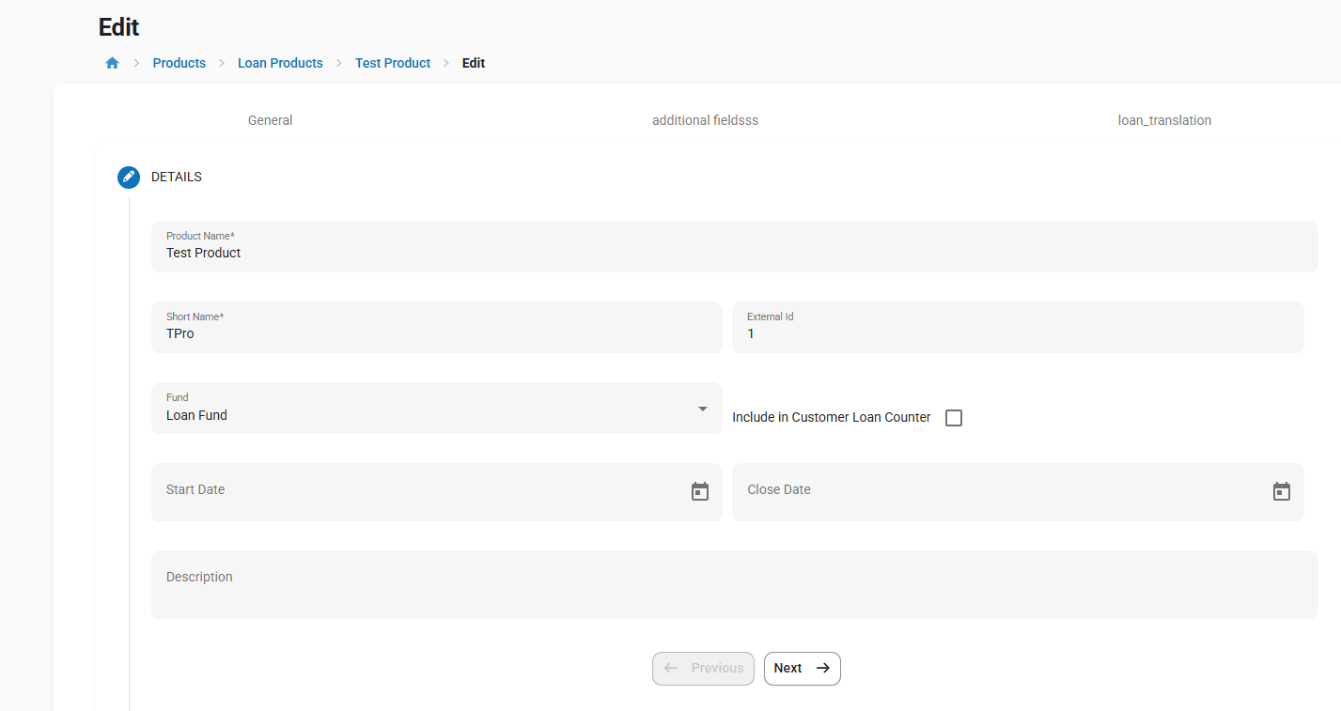

Figure 1 - Loan Product configuration screen

3.1 Required Changes
Enhance the existing Loan Product screen by adding the following fields in the General → Details section, preferably after Fund and before Start Date.
Field | Type | Mandatory | Default | List of Values | Description
Islamic Product | Boolean | Yes | No | Yes, No | Identifies whether the product is Conventional or Islamic.
Financing Type | Dropdown | Conditional | Murabaha | Murabaha | Defines the Islamic financing contract associated with the product. Displayed only when Islamic Product = Yes.

3.2 Business Rules
- Existing conventional products shall remain unchanged.
- Existing interest calculation engines shall be reused for Islamic products.
- For Islamic products, interest-related labels shall be displayed as profit-related labels.
- Financing Type shall only be displayed when Product Type = Islamic.
- For MVP, only Murabaha shall be supported.
- Existing loan product interest configuration shall remain technically available and used for schedule calculation.
- Existing loan products, APIs, schedules, accounting behavior, and repayment processing shall remain backward compatible.

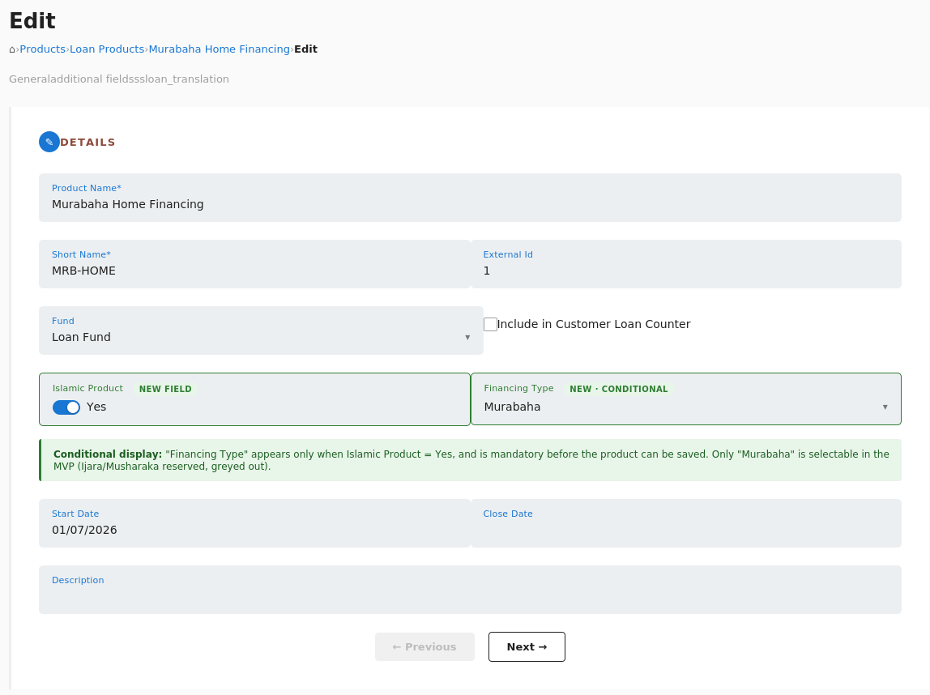

Figure 2 - Loan Product configuration screen: "Islamic Product" toggle and conditional "Financing Type" dropdown

3.3 Validations
Validation | Expected Behavior
Islamic Product = No | Islamic-specific fields shall not be displayed.
Islamic Product = Yes | Financing Type is mandatory.
Islamic Product = Yes & Financing Type not selected | Product cannot be saved.

3.4 Impact
The enhancement shall affect only Loan Products configured as Islamic products.
Existing conventional products, APIs, schedules, accounting behavior, and loan processing shall remain fully backward compatible.

4. Terminology Mapping
Introduce Islamic terminology support that allows the Loan Management System to display Shariah-compliant labels for Islamic financing products, in place of the default conventional system labels.
Delivery Mechanism: Islamic Labels configuration file.

4.1 Required Changes
For the MVP, terminology customization for Islamic financing products shall be delivered through a dedicated Islamic Labels configuration file, following the same approach already used by the platform's existing labels file, rather than through a new administrative screen.
● Create a new Islamic Labels file, structured in the same format as the platform's existing system labels file, containing one entry per System Term and its corresponding Islamic Term.
● Populate the Islamic Labels file with the default terminology mappings defined in Section 4.2.
● Extend the existing label-resolution mechanism so that, for any screen, report, or API display field, the system resolves labels from the Islamic Labels file when the associated Loan Product has Islamic Product = Yes, and from the default labels file when Islamic Product = No.

4.2 Default Label File Values

System Term | Islamic Value - EN | Islamic Value - FR
Loan | Financing | Financement
Loan Product | Financing Product | Produit de financement
Loan Account | Financing Account | Compte de financement
Loan Transaction | Financing Transaction | Transaction de financement
Loan Officer | Financing Officer | Chargé de financement
Borrower | Customer | Client
Principal | Financing Amount | Montant du financement
Interest | Profit | Profit
Interest Rate | Profit Rate | Taux de profit
Interest Waiver | Profit Waiver | Renonciation au profit
Interest Refund | Profit Refund | Remboursement du profit
Total Due | Installment Amount | Montant de l'échéance
Principal Due | Financing Amount Due | Montant du financement dû
Interest Due | Profit Due | Profit dû
Fee Charges Due | Fee Charges Due | Frais dus
Penalty Charges Due | Penalties Due | Pénalités dues
Total Due For Period | Installment Amount | Montant de l'échéance

4.3 Business Rules
● The Islamic Labels file shall only be loaded when the Islamic Financing Module is enabled at the tenant level (see Section 2).
● Default terminology mappings shall be predefined by the system, as listed in Section 4.2.
● Label selection shall be evaluated per Loan Product / Financing Account, based on the Islamic Product flag (Yes/No) defined at product creation (see Section 3.1): Loan Products with Islamic Product = Yes shall use the Islamic Labels file; Loan Products with Islamic Product = No shall continue using the default system labels.
● A financial institution may offer conventional and Islamic products simultaneously; label selection shall be resolved per screen/record based on the underlying product or account, not applied tenant-wide.
● For the MVP, the Islamic Labels file shall be a static, predefined configuration file and shall not be editable through the application UI or API.
● Updating label values for MVP shall require a configuration/deployment change; a self-service editing capability may be introduced in a future phase (see Section 11.6, marked as Future Phase).
● Label changes shall affect UI display labels only.
● Label changes shall not change database field names, API field names, accounting logic, or calculation logic.

4.4 Scope
The terminology defined in the Islamic Labels file shall be applied consistently across:
● Loan Product screens
● Financing creation
● Financing details
● Repayment schedules
● Transactions
● Customer statements
● Advices
● Reports
● Dashboard widgets
● Search screens
● APIs (Display fields only, where applicable)
● Digital Channels (if labels are rendered from CBS)

5. Financing Creation
Enhance the existing Financing Creation process to support Islamic financing products.
Navigation
Customers → Loans → Create New Loan
Note: The existing screen and workflow shall be reused. Additional fields shall be displayed only when an Islamic financing product is selected.

5.1 Required Changes
When an Islamic product is selected, enhance the Financing Creation (Loan Creation) screen by adding the following section.
New Section: Commodity Details
Place this section immediately after the Loan Details section and before the Terms section.
The LMS integrates with the external Commodity Management System (CMS) to retrieve commodity master data. The user selects a commodity by identifier; the system auto-populates read-only reference fields; Cost Price is always captured/editable at the LMS level regardless of any default supplied by the CMS.
Field | Type | Mandatory | Editable in LMS | List of Values | Description
Commodity | Lookup | Yes | Yes | Commodity Master | Commodity being financed.Validated against the CMS before the field is accepted
Commodity Name | Text | No | No | CMS auto populated | Read-only display once Commodity Id is validated.
Supplier ID | Text | No | No | CMS auto populated | Read-only display; left blank if not returned by CMS.
Cost Price | Amount | Yes | Yes | Prefilled from CMS if a default is returned, but always remains editable. | Purchase price of the commodity.

Sequence
1. User enters or searches a Commodity Id.
2. LMS calls the CMS GET /commodities/{commodityId} endpoint.
3. On success (200): populate Commodity Name and Supplier Id (if present), and optionally prefill Cost Price.
4. On not-found (404) or an inactive commodity: block the field and show the validation message
5. On timeout/unavailable (5xx or network error): show the message defined in 5.4.8 and block submission, unless a previously validated commodity is already cached per the approved caching rule.

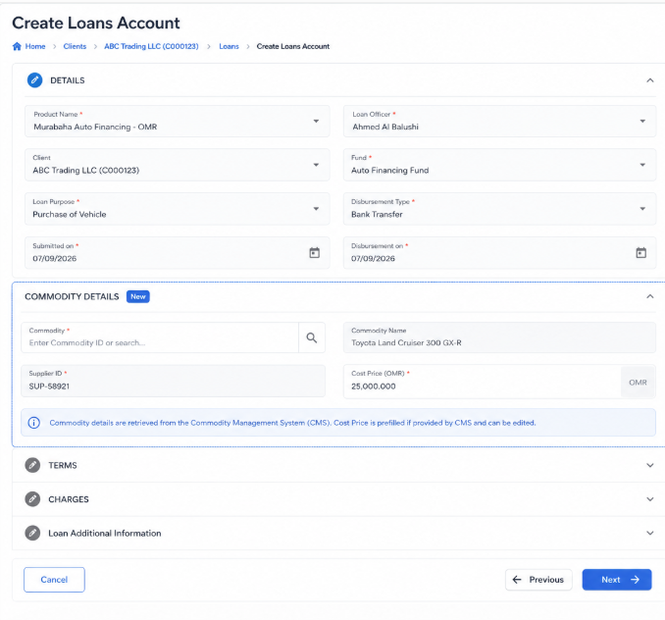
Figure 4 - Commodity section

5.2 Business Rules
- This section shall only be displayed when the selected product is configured as Islamic.
- The existing financing creation process shall remain unchanged for conventional products.
- Commodity information shall be retrieved from the external Commodity Management System (CMS).
- Commodity Name and Supplier information shall be automatically populated after a successful commodity lookup.
- Cost Price may be prefilled from the CMS but shall remain editable.
- Selling Price shall be automatically calculated as:Selling Price = Cost Price + Profit Amount
- Financing Amount (Principal) shall be equal to the Cost Price.
- Commodity information shall be stored as part of the financing record.
- Commodity information shall become read-only after financing approval.
- Financing creation shall not be completed if mandatory commodity information cannot be validated.

5.3 Validations
Validation | Expected Behavior | Error Message
Islamic Product selected | The Commodity Details section shall be displayed.
Commodity is mandatory | Financing cannot be submitted without selecting a valid commodity. | Commodity selection is required for Murabaha financing.
Commodity validation | The selected commodity shall exist in the external Commodity Management System (CMS). | The selected commodity is invalid or unavailable.
Cost Price | Cost Price is mandatory and must be greater than zero. | Cost Price is required and must be greater than zero.
Selling Price | Selling Price shall be automatically calculated by the system and cannot be manually edited. | Selling Price could not be calculated.
Financing Amount | Financing Amount shall be equal to the Cost Price. | Financing Amount must match the Cost Price.
CMS Availability | Financing submission shall be blocked if commodity validation cannot be completed due to CMS unavailability.  Display this message: | Commodity service is currently unavailable. Please try again later

5.4 Existing Screen Changes
The following existing fields shall be relabeled when the selected product is Islamic (As defined in section 4)
Existing Label | Islamic Label
Principal | Financing Amount
Interest Rate | Profit Rate
Interest | Profit
The calculation logic of the existing financing engine shall remain unchanged.

6. Financing Schedule
Enhance the existing repayment schedule generation to support Islamic financing products while reusing the existing schedule generation engine.
Navigation: Customers → Loans → Create Financing → Preview Schedule

6.1 Required Changes
When an Islamic financing product is selected, the existing repayment schedule shall be enhanced as per section (4.1)
Existing Column Changes
Existing Label | Islamic Label
Principal | Financing Amount
Interest | Profit
Total Due | Installment Amount

6.2 Business Rules
- The existing schedule generation engine shall be reused.
- Existing installment calculation logic shall remain unchanged.
- Profit shall be distributed using the existing interest allocation mechanism.
- The repayment schedule shall display Profit instead of Interest.
- The financing amount (Principal) shall equal the Cost Price. Selling Price remains a derived, read-only total (Cost Price + Profit) used for schedule preview and display purposes only, and is not used as the schedule's principal base.
- The total financing amount shall equal the Cost Price.
- The repayment schedule shall become read-only after financing approval.

6.3 Validations
Validation | Expected Behavior
Financing Amount <> Cost Price | Schedule generation shall not proceed.
Profit calculation missing | Schedule generation shall fail.
Invalid installment calculation | Financing cannot be submitted.

6.4 Impact
This enhancement applies only to Islamic financing products.
The repayment schedule for conventional products shall remain unchanged.

7. Financing Account – General Tab

Enhance the existing General tab of the Financing Account to display key Islamic financing information.
Navigation: Customers → Financing → Select Financing Account → General

7.1 Required Changes
When the financing account is associated with an Islamic financing product, enhance the General tab by adding a new section named Islamic Financing Summary.
The Islamic Financing Summary section shall be displayed immediately below the account header and above the existing Performance History section.
Field | Type | Editable | Description
Financing Type | Text | No | Displays the financing type associated with the financing account. For the MVP, the value shall be Murabaha.
Commodity | Text | No | Displays the commodity name selected during financing creation.
Selling Price | Amount | No | Displays the total Murabaha selling price (Cost Price + Profit).

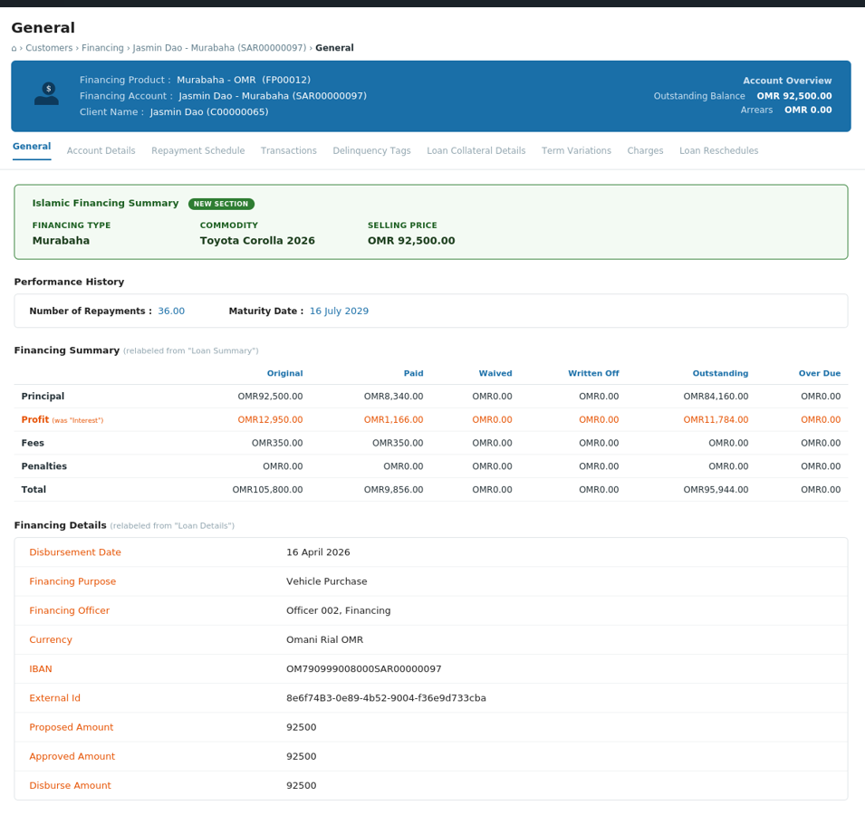
Figure 5 - General tab: new "Islamic Financing Summary" section added above Performance History

7.2 Business Rules
- The Islamic Financing Summary section shall only be displayed when the financing account is linked to an Islamic financing product.
- Conventional financing accounts shall continue using the existing General tab without modification.
- All fields shall be displayed as read-only.
- Selling Price shall be retrieved from the financing record and shall not be recalculated when viewing the account.
- Labels displayed on the screen shall follow the configured Islamic Terminology.

7.3 Validations
Validation | Expected Behavior | Error Message
Islamic financing account | Display the Islamic Financing Summary section. | N/A
Conventional financing account | Do not display the Islamic Financing Summary section. | N/A
Commodity information unavailable | Display the Commodity field as N/A. | "Commodity information is not available."
Selling Price unavailable | Display the Selling Price field as N/A. | "Selling Price information is not available."

7.4 Impact
- The enhancement shall apply only to Islamic financing accounts.
- Existing conventional financing accounts shall remain unchanged.
- The enhancement is display-only and shall not impact financing calculations, accounting, repayment processing, or APIs.

8. Financing Account Details
Enhance the existing Account Details screen to display Murabaha-specific financing information for Islamic financing accounts.
Navigation
Customers → Loans → Select Financing Account → Account Details
The existing Account Details screen shall be reused. A new section shall be displayed only when the account is linked to an Islamic financing product.

8.1 Required Changes
Add a new section named: ‘Islamic Financing Details’
Place the section within the existing Account Details tab, after the general account information and before transaction-related information.
Field | Type | Editable | Description
Financing Type | Text | No | Displays the financing type configured on the product. For MVP, the value is Murabaha.
Commodity ID | Text | No | Displays the commodity identifier selected during financing creation.
Commodity Name | Text | No | Displays the commodity name retrieved from the Commodity Management System.
Supplier ID | Text | No | Displays the supplier identifier returned by the Commodity Management System, when available.
Cost Price | Amount | No | Displays the commodity purchase price captured during financing creation.
Profit | Amount | No | Displays the total profit calculated by the existing financing calculation engine.
The system shall use the account currency and configured currency precision when displaying financial amounts.
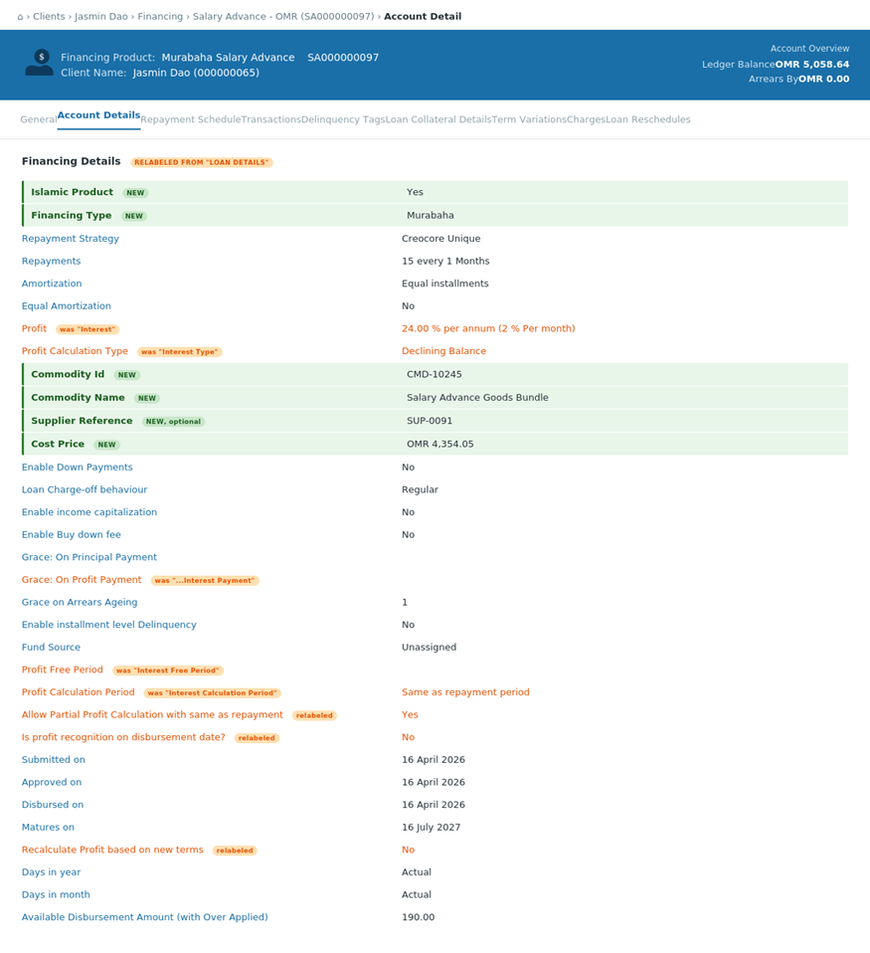Figure 6 - Account Details screen: existing fields relabeled per Terminology Mapping, plus new "Islamic Financing Details" section

8.2 Business Rules
- The Islamic Financing Details section shall only be displayed when the financing account is linked to a product where Islamic Product = Yes.
- Conventional loan accounts shall continue using the existing Account Details screen without modification.
- All fields in this section shall be read-only.
- Commodity information shall be retrieved from the financing record and shall not require a new CMS call when the Account Details screen is opened.
- The displayed Cost Price shall be the final value saved during financing creation.
- Profit shall be derived from the existing interest calculation engine.
- Selling Price shall equal Cost Price plus the total calculated Profit.
- Terminology displayed on the screen shall follow the configured Islamic Terminology mapping.
- Database field names, API attributes, accounting logic, and schedule calculation logic shall remain unchanged unless explicitly stated elsewhere in this FRD.
- Reversed, rescheduled, or modified financing accounts shall retain the original commodity and Cost Price information for audit purposes.

8.3 Validations and Display Handling
Validation / Condition | Expected Behavior | Message
Islamic financing account | Display the Islamic Financing Details section. | N/A
Conventional account | Do not display the Islamic Financing Details section. | N/A
Supplier ID was not returned by CMS | Display the field as blank or N/A. | N/A
Commodity information is unavailable in the financing record | Display the section with unavailable fields marked as N/A. | “Commodity information is not available for this financing account.”
Profit cannot be derived | Selling Price shall not be displayed as a valid amount. | “Financing profit information could not be retrieved.”
Selling Price does not equal Cost Price plus Profit | Log a data-consistency error and display the stored values without recalculating or overwriting them. | “Financing pricing information is inconsistent. Please contact support.”

8.4 Impact
- No changes shall be made to existing conventional account details.
- No editable Murabaha fields shall be introduced on the Account Details screen.
- No new accounting entries shall be generated by viewing this section.
- The enhancement is display-only and shall not affect ledger balance, available balance, profit accrual, repayment allocation, taxation, or reconciliation.

9. Financing Repayment
Enhance the existing repayment process to support Islamic financing accounts while reusing the existing loan repayment and allocation engine.
Navigation: Customers → Financing Account → Actions → Make Repayment
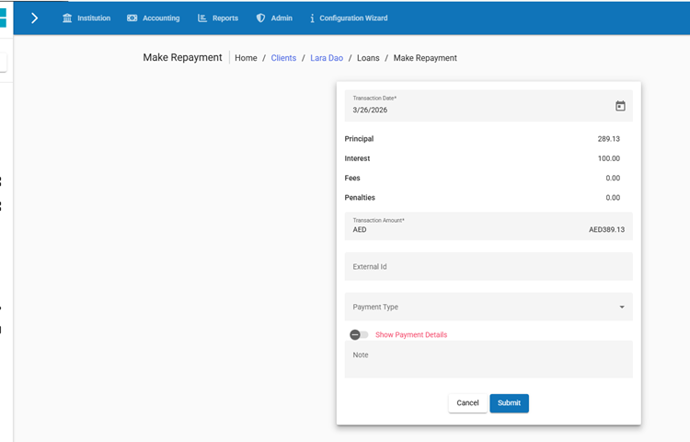

9.1 Required Changes
The existing Make Repayment screen shall be reused.
When the selected account is linked to an Islamic financing product:
- The screen shall display the labels configured under Islamic Terminology.
- Existing interest-related fields shall be displayed using the configured profit terminology.
- No new repayment fields shall be introduced for the MVP.
- No commodity information shall be displayed on the repayment screen.

9.2 Payment Allocation
The existing transaction allocation sequence shall remain unchanged.
The repayment amount may be allocated to the following components according to the product’s configured repayment strategy:
Existing Component | Islamic Display Label
Principal | Financing Amount
Interest | Profit
Fees | Fees
Penalties | Penalties
The displayed labels shall be retrieved from the Islamic Terminology configuration and shall not be hardcoded on the repayment screen.

9.3 Business Rules
- No new repayment calculation engine shall be introduced.
- No changes shall be made to conventional loan repayment processing.
- Existing repayment APIs shall remain backward compatible.
- The main change is the application of Islamic display terminology for Islamic financing accounts.

10. Financing Transactions
Enhance the existing Transactions tab to display Islamic financing transactions using the configured Islamic terminology.
Navigation
Customers → Financing Account → Transactions

10.1 Required Changes
The existing Transactions list and Transaction Details screens shall be reused.
For Islamic financing accounts:
- Transaction labels shall follow the Islamic Terminology configuration.
- Interest-related transaction components shall be displayed as Profit-related components.
- Existing database transaction types and internal transaction codes shall remain unchanged.
- No commodity information shall be added to the transaction listing.

10.2 Transaction List
The existing transaction columns shall remain unchanged unless their labels are included in the Islamic Terminology configuration.
Examples include:
Existing Label | Islamic Display Label
Loan Transaction | Financing Transaction
Principal | Financing Amount
Interest | Profit
Interest Waiver | Profit Waiver
Interest Refund | Profit Refund
The final displayed labels shall be retrieved from the configured terminology mapping.

10.3 Transaction Details
The existing Transaction Details view shall continue displaying:
- Transaction ID, Transaction Type, Transaction Date, Submitted Date, Amount, Financing Amount component, Profit component, Fees, Penalties, Payment Type, External Reference, Reversal status, Journal-entry reference, where currently available
No new editable fields shall be introduced.

10.4 Business Rules
- The enhancement applies only to the presentation of Islamic financing transactions.
- Existing transaction processing and accounting behavior shall remain unchanged.
- Existing transaction APIs shall remain backward compatible.

11. API Requirements
Enhance the existing Loan Management System APIs to support Islamic financing attributes while preserving backward compatibility for conventional loan products and existing API consumers.
No existing API field shall be renamed or removed. Islamic financing attributes shall be added as optional fields and populated only when the related product or account is configured as Islamic.

11.1 Loan Product API Enhancement
Enhance the existing Loan Product create, update, and retrieve APIs by adding the following fields
Field | Type | Mandatory | Applies When | Description
isIslamicProduct | Boolean | Yes | Module enabled | Identifies whether the product is Islamic.
financingType | String | Conditional | isIslamicProduct = true | Defines the financing contract. For the current supported version, the value is MURABAHA.
List of Values - financingType
API Value | Display Value
MURABAHA | Murabaha
Request Example
{
"name": "Murabaha Vehicle Financing",
"shortName": "MVF",
"currencyCode": "AED",
"digitsAfterDecimal": 2,
"isIslamicProduct": true,
"financingType": "MURABAHA"
}
Response Example
{
"id": 101,
"name": "Murabaha Vehicle Financing",
"shortName": "MVF",
"currencyCode": "AED",
"isIslamicProduct": true,
"financingType": {
"code": "MURABAHA",
"value": "Murabaha"
}
}
Business Rules
- financingType shall be mandatory when isIslamicProduct = true.
- financingType shall be null or omitted when isIslamicProduct = false.
- Existing conventional product payloads shall continue to be accepted without the new fields.
- Existing interest configuration fields shall continue to be used for profit calculation.

11.2 Financing Creation API Enhancement
Enhance the existing loan account creation API to capture Islamic financing and commodity information.
New Request Fields
Field | Type | Mandatory | Description
commodityId | String | Yes | Commodity identifier selected from the configured external Commodity Service.
commodityName | String | No | Commodity name returned by the external Commodity Service.
supplierReference | String | No | Supplier or vendor reference returned by the external Commodity Service.
costPrice | Decimal | Yes | Commodity purchase price.
sellingPrice | Decimal | System calculated | Total Murabaha selling price.
financingType | String | Response / derived | Financing type inherited from the selected product.
Request Example
{
"clientId": 5001,
"productId": 101,
"principal": 95000.00,
"submittedOnDate": "10 July 2026",
"expectedDisbursementDate": "15 July 2026",
"commodityId": "CMD-100458",
"costPrice": 95000.00,
"locale": "en",
"dateFormat": "dd MMMM yyyy"
}
Response Example
{
"loanId": 90001,
"resourceId": 90001,
"isIslamicProduct": true,
"financingType": "MURABAHA",
"commodity": {
"commodityId": "CMD-100458",
"commodityName": "Vehicle Commodity",
"supplierReference": "SUP-2201"
},
"costPrice": 95000.00,
"profitAmount": 12000.00,
"sellingPrice": 107000.00,
"financingAmount": 95000.00
}
Business Rules
- Commodity fields shall be accepted only for Islamic financing products requiring commodity information.
- The selected commodity shall be validated through the configured external Commodity Service before submission.
- costPrice shall remain an LMS-managed value even when prefilled from the external service.
- sellingPrice shall be system calculated and shall not be accepted as an editable client-supplied value.
- The existing principal field shall continue to represent the Financing Amount.
- The Financing Amount (Principal) shall equal the Cost Price.
- Existing conventional financing requests shall remain unchanged.

11.3 Financing Details API Enhancement
Enhance the existing financing account retrieval APIs to expose Islamic financing information.
New Response Object
{
"islamicFinancingDetails": {
"isIslamicProduct": true,
"financingType": "MURABAHA",
"commodityId": "CMD-100458",
"commodityName": "Vehicle Commodity",
"supplierReference": "SUP-2201",
"costPrice": 95000.00,
"profitAmount": 12000.00,
"sellingPrice": 107000.00
}
}
Business Rules
- islamicFinancingDetails shall be returned only for Islamic financing accounts.
- Commodity information shall be retrieved from the financing record.
- Retrieving financing details shall not trigger a new external Commodity Service call.
- Financial values shall use the account currency and configured currency precision.
- Islamic financing details shall be read-only after financing approval.

11.4 Repayment Schedule API
The existing repayment schedule API shall continue using the current response structure.
No calculation fields shall be renamed at API level to preserve backward compatibility.
Existing Technical Fields
Existing API Field | Islamic Business Meaning
principalDue | Financing Amount Due
interestDue | Profit Due
feeChargesDue | Fees Due
penaltyChargesDue | Penalties Due
totalDueForPeriod | Installment Amount
Optional Display Labels
Where the API already returns display metadata, the response may include configured Islamic labels.
{
"displayLabels": {
"principal": "Financing Amount",
"interest": "Profit",
"totalDue": "Installment Amount"
}
}
Business Rules
- Existing schedule calculation and response fields shall remain unchanged.
- Existing API consumers shall not be required to update their technical mappings.
- Digital channels may use displayLabels where labels are rendered dynamically.
- Profit shall continue to be technically represented through the existing interest components.

11.5 Repayment and Transaction API
The existing repayment and transaction APIs shall remain backward compatible.
Repayment Request Example
{
"transactionDate": "10 July 2026",
"transactionAmount": 5000.00,
"paymentTypeId": 1,
"externalId": "PAY-20260710-0001",
"locale": "en",
"dateFormat": "dd MMMM yyyy"
}
No Islamic-specific repayment input fields are required.
Transaction Response Example
{
"transactionId": 78001,
"transactionType": "REPAYMENT",
"amount": 5000.00,
"principalPortion": 4200.00,
"interestPortion": 700.00,
"feePortion": 100.00,
"penaltyPortion": 0.00,
"isIslamicFinancing": true,
"displayComponents": {
"financingAmount": 4200.00,
"profit": 700.00,
"fees": 100.00,
"penalties": 0.00
}
}
Business Rules
- Existing repayment allocation logic shall remain unchanged.
- Existing interestPortion shall technically continue to represent the allocated Profit.
- New display-oriented fields may be added without removing existing transaction components.
- Existing transaction types, reversals, refunds, and waivers shall continue using existing internal codes.
- No new Islamic repayment transaction type shall be introduced for the current scope.

11.6 Terminology API
Introduce an API to retrieve and maintain Islamic terminology mappings.
Retrieve Terminology
GET /islamic-financing/terminology
Response Example
{
"mappings": [
{
"systemLabel": "Loan",
"islamicLabel": "Financing"
},
{
"systemLabel": "Interest",
"islamicLabel": "Profit"
},
{
"systemLabel": "Principal",
"islamicLabel": "Financing Amount"
}
]
}
Update Terminology
PUT /islamic-financing/terminology
Request Example
{
"mappings": [
{
"systemLabel": "Loan",
"islamicLabel": "Financing"
},
{
"systemLabel": "Interest",
"islamicLabel": "Profit"
}
]
}
Business Rules
- Only predefined system labels shall be returned.
- Users shall only be allowed to update the Islamic label.
- Terminology APIs shall be available only when the Islamic Financing Module is enabled.
- Terminology changes shall not alter database fields, internal API fields, accounting codes, or calculation logic.
- Updates shall require appropriate permission and shall be audited.

11.7 Commodity Service Integration API
The LMS shall integrate with a configurable external Commodity Service.
The exact endpoint structure and authentication mechanism shall be defined in the integration specification.
Required Service Operations
Operation | Purpose
Search Commodity | Retrieve available commodities based on search criteria.
Retrieve Commodity | Retrieve details for a selected commodity identifier.
Validate Commodity | Confirm that the commodity is valid and active.
Normalized Commodity Response
{
"commodityId": "CMD-100458",
"commodityName": "Vehicle Commodity",
"supplierReference": "SUP-2201",
"defaultCostPrice": 95000.00,
"currency": "AED",
"status": "ACTIVE"
}
Business Rules
- The LMS shall normalize external commodity responses into a standard internal structure.
- Supplier information shall be optional.
- Default Cost Price may be returned but shall remain editable in LMS.
- An inactive or invalid commodity shall not be accepted.
- Integration credentials and endpoint configuration shall be tenant-specific.

11.8 Idempotency
The following operations shall support duplicate prevention:
- Financing creation.
- Repayment posting.
- External commodity validation where the integration supports request identifiers.
- Any future accounting export or event publication.
Requirements
- Requests initiated by external channels shall support an idempotency key or unique external reference.
- Repeated requests using the same key shall not create duplicate financing accounts or transactions.
- The system shall return the previously created resource or a duplicate-request response according to the existing API framework.
- Idempotency records shall be tenant-isolated.

11.9 Retry and Failure Handling
- Read-only Commodity Service requests may be retried automatically for transient network or server failures.
- Retry intervals and maximum retry attempts shall be configurable at integration level.
- Validation failures and business errors shall not be retried.
- Financing submission shall remain blocked when commodity validation cannot be completed.
- Failed external calls shall be logged with tenant ID, request reference, service name, response code, and timestamp.

11.10 Security and Permissions
- All APIs shall use the existing authentication and authorization framework.
- Islamic product configuration APIs shall require product-management permissions.
- Terminology update APIs shall require Islamic terminology configuration permissions.
- Financing creation APIs shall require existing loan/financing creation permissions.
- Commodity integration credentials shall not be exposed in API responses.
- Tenant data shall remain isolated across all API operations.

11.11 Audit Requirements
The existing audit framework shall capture API-driven changes to:
- Islamic Product flag.
- Financing Type.
- Commodity ID and Commodity Name.
- Supplier Reference.
- Cost Price.
- Islamic terminology mappings.
- Financing creation and approval.
- Repayment, reversal, refund, and waiver operations.
Audit records shall include the user or integration identity, tenant, timestamp, request reference, old value, and new value where applicable.

11.12 Backward Compatibility
- Existing API endpoints shall remain available.
- Existing request and response fields shall not be renamed or removed.
- New Islamic financing fields shall be optional for conventional products.
- Conventional product and financing responses shall remain unchanged unless optional module metadata is requested.
- Existing digital channels and integrations shall continue operating without mandatory payload changes.
- API versioning shall follow the existing product API versioning policy.

12. External Commodity Service Integration
The Islamic Financing Module requires commodity information for financing products that are based on commodity transactions, such as Murabaha.
The system shall support commodity information through either:
- FOO Commodity Management Module (if licensed and enabled), or
- Integration with an external Commodity Management System.
The commodity source shall be configurable at the tenant level.

12.1 Supported Deployment Models
The system shall support the following deployment models:
Model | Description
FOO Commodity Management Module | Commodity information is managed within the FOO platform.
External Commodity Management System | Commodity information is retrieved from an external system through configurable integration APIs.

12.2 Functional Requirements
The system shall support the following operations:
Capability | Description
Search Commodity | Search and select a commodity during financing creation.
Commodity Validation | Validate that the selected commodity is available for financing.
Commodity Retrieval | Retrieve commodity information from the configured commodity source.
Commodity Storage | Store the selected commodity reference as part of the financing record.
Commodity Display | Display commodity information throughout the financing lifecycle.

12.3 Business Rules
- The commodity source shall be configurable per tenant.
- Commodity information shall only be required for financing products configured to use commodities.
- Commodity information shall become read-only after financing approval.
- The final Cost Price shall be stored as part of the financing record.
- The LMS shall not manage commodity ownership, inventory, trading, or pricing lifecycle.
- Changes made to commodity information after financing approval shall not modify existing financing contracts.
- Conventional loan products shall not require commodity information.

12.4 Validation
Validation | Expected Behavior | Error Message
Commodity not selected | Financing cannot be submitted. | "Commodity selection is required."
Invalid commodity | Financing cannot be submitted. | "The selected commodity is invalid or unavailable."
Commodity information unavailable | Financing cannot be submitted. | "Commodity details could not be retrieved."
Commodity service unavailable | Financing submission shall be blocked. | "Commodity service is currently unavailable. Please try again later."

12.5 Integration Requirements
The Commodity Management integration shall:
- Support integration with the FOO Commodity Management Module or an external Commodity Management System.
- Allow retrieval and validation of commodity information during financing creation.
- Store commodity references as part of the financing record.
- Support configurable integration endpoints and authentication mechanisms.
- Be extensible to support different commodity providers without requiring changes to the Islamic Financing Module.
The detailed API specifications, payload structures, authentication mechanisms, retry policies, and error handling shall be defined in the Integration Specification.

12.6 Impact
- The enhancement applies only to Islamic financing products that require commodity information.
- Existing conventional loan products shall remain unchanged.
- Commodity information shall be available throughout the financing lifecycle for display, reporting, and audit purposes.
- The Islamic Financing Module shall operate independently of the selected commodity source.

13. Accounting Impact
The Islamic Financing Module shall reuse the existing accounting engine and journal posting framework.
No separate accounting engine shall be introduced for Islamic financing.

14. Permissions & Maker-Checker
Define the security permissions required to configure and operate the Islamic Financing Module.
The module shall reuse the existing role-based access control and maker-checker framework.
The Islamic Financing Module introduces new configuration screens that require dedicated system permissions. Existing permissions for Loan Products, Financing Creation, Repayments, and Transactions shall continue to be reused.
The following permissions shall be introduced:

Islamic Financing Configuration
- Read Islamic Financing Configuration
- Update Islamic Financing Configuration
- Approve Islamic Financing Configuration Checker

Business Rules
- These permissions shall only be available when the Islamic Financing Module is enabled.
- Users shall only be able to access configuration screens based on their assigned permissions.
- All configuration changes requiring maker-checker approval shall remain in a Pending Approval status until approved by an authorized checker.
- Configuration changes shall not become effective until the approval process is successfully completed.
- Existing CBS role management and maker-checker framework shall be reused.
This keeps the section focused only on the new configuration screens introduced by the module and avoids redefining permissions for existing LMS functionality.

15. Audit & Logging
Ensure that all Islamic Financing activities are fully auditable using the existing audit framework.

15.1 Audited Events
The system shall audit the following activities:
Event | Audit Required
Islamic Financing Module enabled/disabled | Yes
Islamic Product created | Yes
Islamic Product updated | Yes
Financing Type changed | Yes
Terminology Mapping updated | Yes
Islamic Financing created | Yes
Islamic Financing approved | Yes
Commodity changed before approval | Yes
Cost Price updated before approval | Yes
Financing repaid | Yes
Financing reversed | Yes
Financing closed | Yes

15.2 Business Rules
- The existing audit framework shall be reused.
- The existing logging framework shall be reused.
- No additional audit infrastructure shall be required.
- Islamic Financing events shall be captured using the same audit mechanisms as conventional lending.

16. Reporting Impact
Define the reporting impact introduced by the Islamic Financing Module.

16.1 Reporting Requirements
The existing reporting framework shall be reused.
Reports generated for Islamic financing products shall display the configured Islamic terminology while preserving the existing reporting structure.

